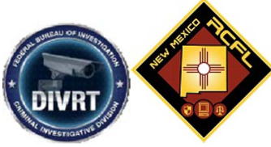

DIVRT Training will be offered at the NMRCFL located at 901 University Blvd. SE, Albuquerque NM, on the following dates: June 7-9, 2022 from 8:00AM – 5:00PM. This is a FREE course. There are ONLY 16 seats available for this three (3) day course..

This course is made available for any Law Enforcement Officers that conduct initial and follow-up investigations. Anyone attending this class must to be present for all three (3) days to successfully complete the course and obtain a certificate. If you have any questions or concerns regarding this course contact:
The NMRCFL through the web page, nmrcfl.org
or
F.E. CJ Brown: cjbrown1@fbi.gov

Course Registration will be available in Appointments Plus for APD personnel through the NMRCFL website.

A waitlist will be maintained in the event of any cancelations.

All attendees must use the parking structure, located at 801 Bradbury SE. Please see attached map. Do NOT Park in the NMRCFL or the UNM Science and Technology Building Parking spaces.

